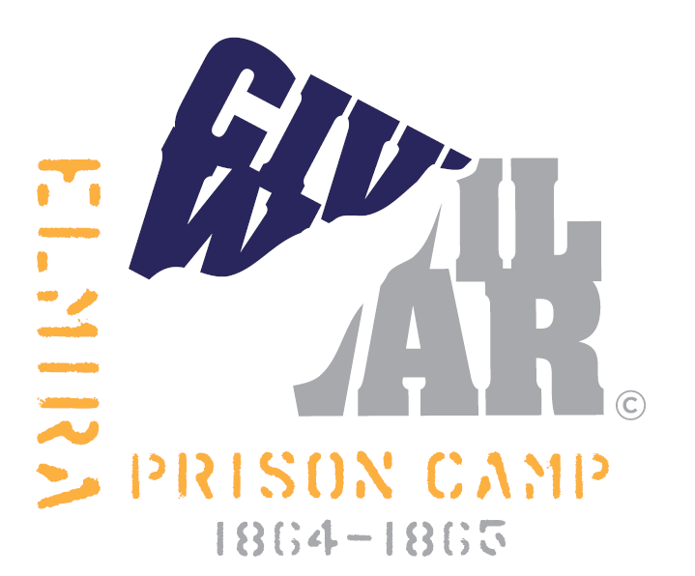
Barracks to Prison Pen
Living History & Preservation Challenge
Registration
Jun 23-25, 2017, Elmira, NY
Sponsored by: The Friends of the Elmira Civil War Prison Camp (501c3 nonprofit)
Elmiraprisoncamp.com

Before submitting payment, you must complete this form & provide a photograph of your planned impression for approval by the appropriate impression coordinator. Email to barracksno3@gmail.com
- Registration is by individual. Registration is not complete until form has been submitted to the respective impression coordinator, photo on file & registration fee is paid. Upon receipt of payment, your name will be added to the event roster and Facebook discussion page.
- Registration fee due by May 31, 2017. NO walk ons.
  - Military - $25 (includes rations per the historical record)
  - Civilian - $20
  - Payment via Paypal (Yellow donate button at top of webpage-Preferred) or
Mail: Check payable to FECWPC, 2627 Comfort Hill Rd, Wellsburg, NY 14894 (allow at least 7 working days from mailing for acknowledgement of receipt)
  - All unused registration funds will be donated to Friends of the Elmira Civil War Prison Camp.
- All participants are challenged, but not required, to raise a $75 preservation donation that goes to the Friends of the Elmira Civil War Prison Camp. See the Donation Challenge tab for instructions.
Last Name_________________________ First Name____________________ Email___________________
Mailing Address:____________________________________________________________________________
Email address: _____________________ Tel:_____________
Impression: ___US ____VRC ___USCT ___CS ___Civilian
(* CS registrants may request a specific historical name of one of original first 400 CS POWs from the CS coordinator)
I have a common tent Y N
I want to tent with _______________________________________________________________________
If you do not have a tent or do not indicate tent mate preference, you will be assigned to one by the impression coordinator.
Emergency Contact: ________________________________________________________________________
Do you have any dietary requirements ( i.e. allergy/diabetic/vegetarian etc)? Y N
State condition (responses will be kept confidential): ____________________________________________________________________________
Do you have any allergies or medical conditions? ___Yes ___No If yes, you will be given a tag at registration, that must be kept on your person with the condition for the duration of the event.
Do you have any medical certifications/licenses? Explain__________________________________________
Email completed form to: barracksno3@gmail.com. Submission indicates you have read & agree to the impression guidelines/conditions as established on the website.

